• Why Games in AI?
- From the beginning of computer science, games like chess or tic-tac-toe have been used as testbeds to improve AI.
- Games are good for AI research because they have clear rules and structured environments, making them perfect to train algorithms.
• AI and Games Today
- Modern AI can learn, adapt, and make smart decisions in games.
- This has changed how we play and experience games, making AI an important player in gaming.
• What Knowledge is Needed?
- To program AI for games, we don’t need to give it much knowledge—just the rules of the game, possible moves, and winning/losing conditions.
- Both players (human or AI) simply try to make the best move at each turn.
• Why Not Simple Search?
- Techniques like Breadth-First Search (BFS) are not good for games.
- Reason: in games, the number of possible moves (called branching factor) is very high. Searching all possibilities will take too much time.

👉 In short: Games help us test AI. AI only needs game rules and winning conditions. Simple searches are too slow because games have too many possibilities, so we use special algorithms like Minimax and Alpha-Beta Pruning.

The Minimax Search Algorithm

What is Minimax?
  - Minimax is a common AI technique used in games like chess or tic-tac-toe.
  - It is a depth-first search method that looks ahead at possible moves.
- Why “Mini” and “Max”?
  - Imagine two players:
    - Max = tries to get the best (maximum) score.
    - Min = tries to make the opponent’s score as small as possible.
  - Both assume the other is playing perfectly.
- How does it work?
  - The algorithm builds a game tree of all possible future moves.
  - At each level, it chooses either the move that maximizes gains (Max) or minimizes losses (Min).
- Recursive Nature
  - Minimax works recursively: it keeps going deeper until it reaches the end of the game (like win/loss/draw positions).
  - Then, it works backward to decide the best move at the current step.
- Goal
  - The main goal of Minimax is to maximize the AI’s chance of winning while assuming the opponent also plays their best.
👉 In short: Minimax is a backtracking algorithm for decision making in games. One player tries to maximize their score, the other tries to minimize it. The AI looks ahead at future moves, then backtracks to choose the best move now.

Minimax Algorithm
- Two Players in Minimax
  - There are always two roles:
    - Maximizer → tries to get the highest score.
    - Minimizer → tries to get the lowest score.
- Board Values
  - Every possible board position has a value.
  - If the maximizer is winning → the board value is positive.
  - If the minimizer is winning → the board value is negative.
  - These values are calculated using heuristics (rules that estimate the quality of a position).
- Key Assumption
  - Both players are assumed to play optimally (always make the best move).
  - The maximizer tries to increase gains, while the minimizer tries to reduce losses.
- Final Goal
  - Each player tries to reduce the worst-case loss they could face.
  - This makes Minimax a safe strategy in competitive games.

👉 In short: In Minimax, one player maximizes, the other minimizes. Each board state has a value (positive or negative), and the algorithm assumes both players are smart and always pick the best move.

Working of Minimax

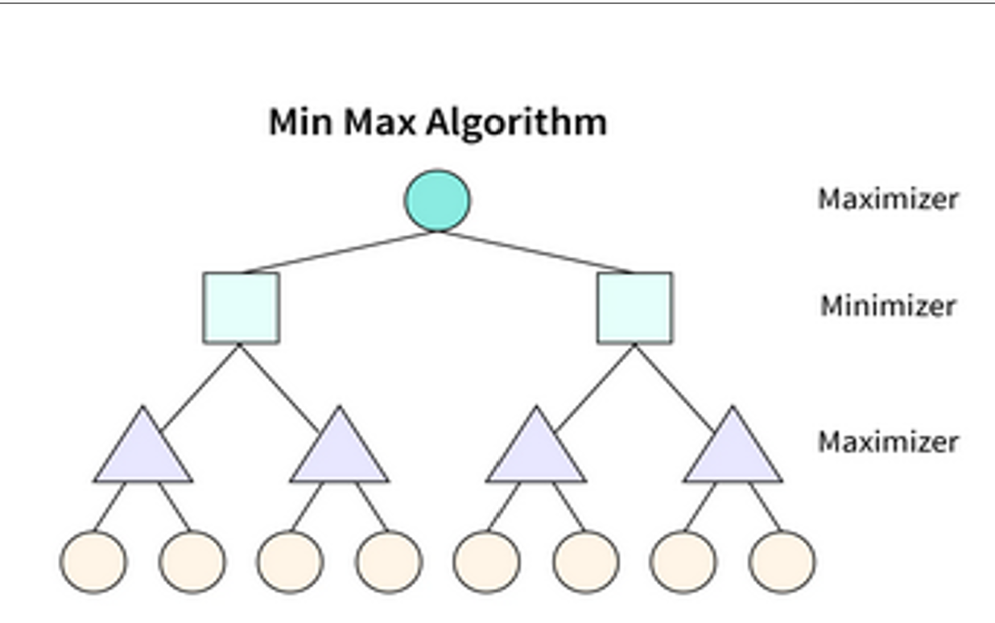

Game Tree
  - The diagram is a game tree.
  - Each level of the tree represents turns:
    - One level is for the Maximizer (tries to get the highest value).
    - The next level is for the Minimizer (tries to get the lowest value).
  - This alternates until we reach the end states (circles at the bottom).
- How the Algorithm Works
  - The algorithm starts at the root node (the top circle).
  - It explores all possible moves and their outcomes by going down the tree.
  - At each node:
    - The Maximizer picks the child node with the highest value.
    - The Minimizer picks the child node with the lowest value.
- Terminal Nodes (Leaves)
  - At the bottom, each leaf node (circle) is given a value (score).
  - This value represents how good or bad that board state is for the player (called the heuristic value).
- Backtracking the Values
  - Once the bottom values are assigned, the algorithm moves upward, alternating between Min and Max.
  - The root finally gets the best possible value, and the AI chooses the corresponding move.

👉 In short:
- Minimax looks at all possible moves ahead.
- Maximizer → picks best (highest value).
- Minimizer → picks worst for opponent (lowest value).
- Values are passed upward, and the AI selects the move that guarantees the best outcome assuming the opponent plays optimally.

Game Theory
- What is Game Theory?
  - Game theory is about mathematical models of decision-making when multiple players are involved.
  - It studies how players make choices and how those choices affect the outcomes.
- Types of Games
  - Complete Information Games → All players know each other’s possible moves and outcomes (e.g., Chess, Tic-Tac-Toe).
  - Incomplete Information Games → Some moves or payoffs are hidden (e.g., Poker).
- Game Tree
  - A game tree is used to represent possible moves in a game.
  - Nodes → represent states of the game.
  - Edges → represent possible moves.
  - Root → starting state.
  - Terminal nodes → outcomes (win, lose, draw).

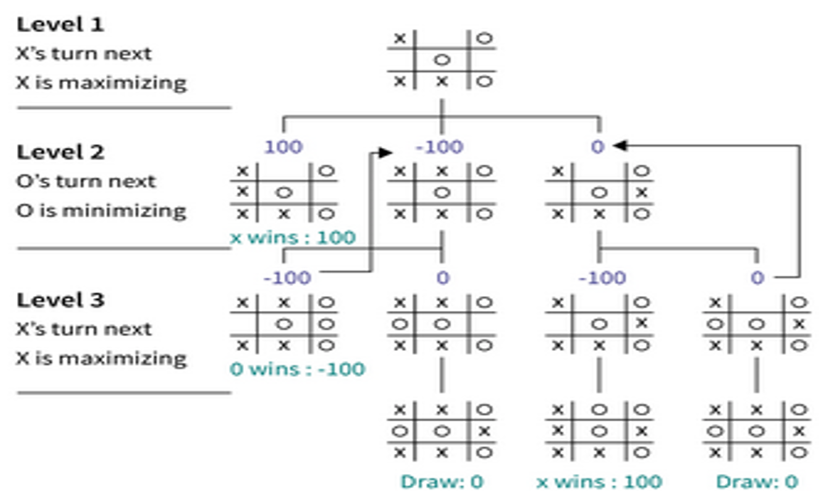

Tic-Tac-Toe Example with Minimax
- Levels of the Tree
  - Level 1: X’s turn → X is the Maximizer (tries to win).
  - Level 2: O’s turn → O is the Minimizer (tries to stop X from winning).
  - Level 3: X’s turn again → Maximizer continues.
- Scoring System (Heuristic Values)
  - If X wins → +100.
  - If O wins → –100.
  - If Draw → 0.
- How It Works
  - At the bottom (Level 3), we assign scores to outcomes.
  - O (minimizer) always picks the lowest score.
  - X (maximizer) always picks the highest score.
  - This way, the best move for X is chosen at the top (root).

👉 In short:
- Game theory studies decision-making in games.
- Minimax applies game theory to find the best move by building a game tree.
- In Tic-Tac-Toe, X maximizes chances of winning, O minimizes them, and scores (+100, –100, 0) guide the AI.

🟢 Step 1: Look at the tree
We have a small game tree:
MAX
/ \
MIN MIN
/ \ / \
3 5 2 9
- Top node = MAXIMIZER (wants the biggest number).
- Next level = MINIMIZER (wants the smallest number).
- Leaves = Final scores (3, 5, 2, 9).

🟢 Step 2: Minimizer’s Turn
- On the left branch → Minimizer chooses between 3 and 5.
  - Minimizer always picks the smaller value → so it picks 3.
- On the right branch → Minimizer chooses between 2 and 9.
  - Minimizer picks the smaller value → so it picks 2.

Now the tree looks like this:
MAX
/ \
3 2

🟢 Step 3: Maximizer’s Turn
- Now it’s Maximizer’s turn at the top.
- Maximizer chooses the largest value from {3, 2}.
- That means Maximizer will pick 3.

✅ Final Answer
- Best move for Maximizer = LEFT branch.
- Value = 3.

👉 Super simple rule to remember:
- MIN takes the minimum at its level.
- MAX takes the maximum at its level.
- Keep working backwards from the leaves.

Explanation of Minimax Pseudo-code

1. Inputs
- node → the current position (state) of the game.
- depth → how far down the tree we want to search.
- maximizingPlayer → Boolean (TRUE if it’s MAX’s turn, FALSE if it’s MIN’s turn).

2. Base Case
if depth = 0 or node is a terminal node:
return the heuristic value of the node
- If we reach the bottom of the tree (leaf) or maximum depth → return the score of that state.

3. If it’s Maximizer’s Turn
bestValue = -∞
for each child of node:
v = minimax(child, depth-1, FALSE) # Now MIN’s turn
bestValue = max(bestValue, v)
return bestValue
- Start with a very low number.
- Look at all possible moves.
- For each move → call minimax again, but now it’s MIN’s turn.
- Take the maximum value among all moves.

4. If it’s Minimizer’s Turn
bestValue = +∞
for each child of node:
v = minimax(child, depth-1, TRUE) # Now MAX’s turn
bestValue = min(bestValue, v)
return bestValue
- Start with a very high number.
- Look at all possible moves.
- For each move → call minimax again, but now it’s MAX’s turn.
- Take the minimum value among all moves.

5. Complexity
- Time Complexity = O(b^d)
  - b = branching factor (average number of moves per state).
  - d = depth (number of moves to look ahead).
- Space Complexity = O(bd), similar to DFS.

👉 Simple Student Analogy
- Maximizer = player trying to score as high as possible.
- Minimizer = opponent trying to bring the score as low as possible.
- Recursive calls → AI imagines future moves until the game ends, then works backwards to decide the best move now.

Explanation of Alpha-Beta Pruning

1. Why Alpha-Beta Pruning?
- In Minimax, the AI explores all possible moves (very slow).
- But many moves don’t change the final decision.
- Alpha-Beta Pruning cuts off (prunes) such unnecessary branches.
👉 Result = faster search, but the answer is still the same as plain Minimax.

2. What are Alpha and Beta?
- Alpha (α) → The best value Maximizer can guarantee so far.
  - Think of it as “the current highest score Max already has.”
- Beta (β) → The best value Minimizer can guarantee so far.
  - Think of it as “the current lowest score Min already has.”

3. How it Works
- While exploring the game tree:
  - If Maximizer already has a better option than the current branch → stop exploring that branch (prune it).
  - If Minimizer already has a worse option than the current branch → stop exploring that branch.
- This avoids checking moves that cannot possibly affect the outcome.

4. Student Analogy
- Imagine you are choosing the best fruit in a basket:
  - If you already found an apple better than all previous ones, you don’t need to check the rotten fruits anymore.
  - Alpha-Beta pruning is like skipping obvious bad choices.

5. Key Point
- Alpha-Beta pruning does not change the result of Minimax.
- It just makes it much faster by ignoring useless branches.

Conditions for Alpha-Beta Pruning

1. Quick Recap
- Alpha (α) = best score Maximizer can guarantee so far.
- Beta (β) = best score Minimizer can guarantee so far.
- At any point, if the algorithm finds that one branch cannot improve the outcome → it prunes (cuts) that branch.

2. When Does Pruning Happen?
- Case 1: Minimizer’s turn
  - If Minimizer finds a value ≤ α → prune.
  - Reason: Maximizer already has a better option, so Maximizer will never let this branch be chosen.
- Case 2: Maximizer’s turn
  - If Maximizer finds a value ≥ β → prune.
  - Reason: Minimizer already has a safer lower option, so this branch is useless.
👉 General condition: prune if α ≥ β.

3. Why Do We Do This?
- It saves time by skipping unnecessary branches.
- It still gives the same final result as Minimax.
- The deeper you search, the more pruning can happen.

🔑 Simple One-Line Rule for Students
“Whenever α ≥ β, prune that branch because it can’t affect the final decision.”

How It Works
- Initialization:
  - α = –∞, β = +∞.
- Max Node:
  - For each child:
    - Evaluate child with Minimax.
    - Update α = max(α, child value).
    - If α ≥ β → prune (Beta cutoff).
- Min Node:
  - For each child:
    - Evaluate child with Minimax.
    - Update β = min(β, child value).
    - If β ≤ α → prune (Alpha cutoff).

Example Walkthrough
- Consider a game tree with branching factor = 2, depth = 3.
- Start at root (Max node), initialize α = –∞, β = +∞.
- Traverse children → update α and β as you go.
- Prune branches where α ≥ β (for Max) or β ≤ α (for Min).
👉 This avoids wasting time on branches that cannot affect the final decision.

✅ In simple terms, you can tell students:
“Alpha-Beta pruning is just like not checking movie tickets for seats we already know are worse than our current best option. It saves time without changing the final result.”
Visit this for example-( https://www.youtube.com/watch?v=9D1hVGumxCo )
clearest step-by-step for the final alpha–beta example.

Alpha–Beta Example (walkthrough)
Tree & roles
- Levels alternate: Max (A), Min (B,C), Max (D,E,F,G), then leaves.
- Start with α = −∞, β = +∞ at the root.

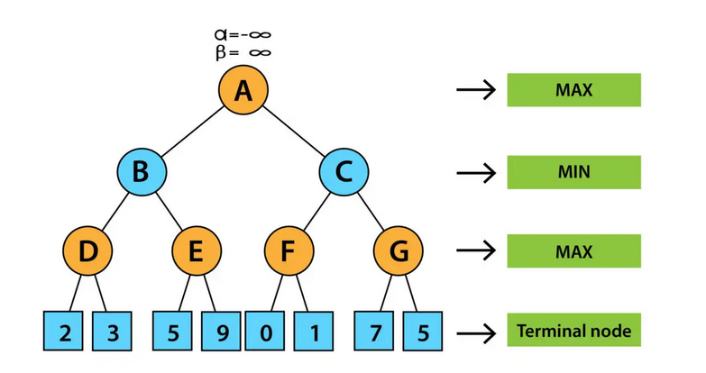

1) Explore left subtree first (A → B)
At D (Max over 2,3)
- Value = max(2,3) = 3
- Bubble up to B (Min): β at B = min(+∞, 3) = 3
- Pass down to E: α = −∞, β = 3
At E (Max over 5,9) with β = 3
- First child 5 → α at E = max(−∞,5) = 5
- Check prune condition at Min parent B: β (3) ≤ α (5) → PRUNE E’s second child (9)
(Because Min at B already has a 3; it won’t allow anything ≥5 anyway.)
- So E = 5, and B = min(3,5) = 3
- Back at root A (Max): α = max(−∞, 3) = 3
Status so far
- Left side decided: B = 3
- Root has α = 3, β = +∞

2) Move to right subtree (A → C)
At C (Min), carry α = 3, β = +∞
At F (Max over 0,1)
- Evaluate 0 → α at F = 0
- Evaluate 1 → α at F = max(0,1) = 1
- So F = 1
- Update β at C = min(+∞, 1) = 1
Prune at C before exploring G
- Check α ≥ β at C → 3 ≥ 1 → PRUNE the entire G subtree
(Because Min at C already can force 1, which is ≤ 3; Max at A won’t get anything better by exploring G.)
So C = 1.

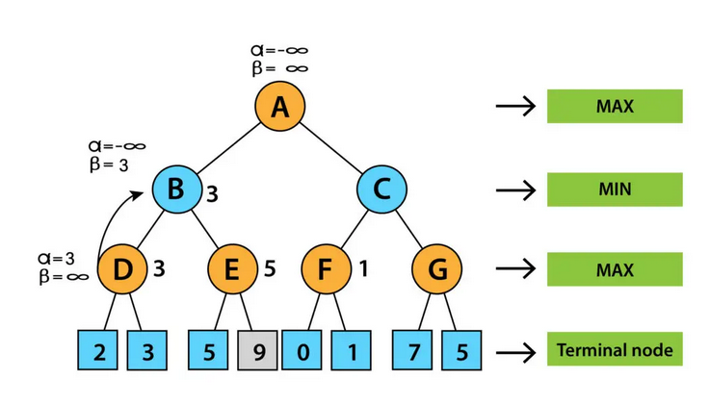3) Final decision at root A (Max)
- Left branch value = B = 3
- Right branch value = C = 1
- A = max(3,1) = 3 → choose LEFT.
- “At E, after seeing 5 and knowing B already had 3, we prune 9 (β=3 ≤ α=5).”
- “At C, after F = 1, root α is 3, so α ≥ β (3 ≥ 1) — we prune G completely.”
- “Result at root is 3; Max goes LEFT.”

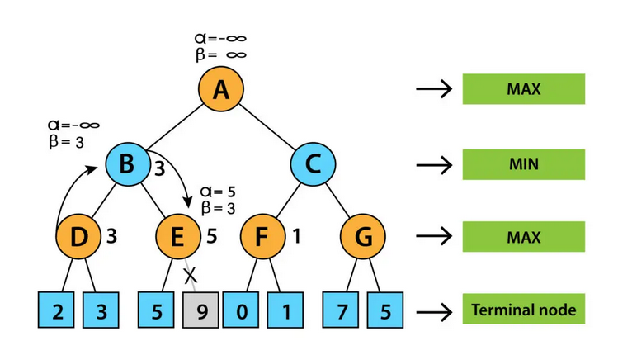

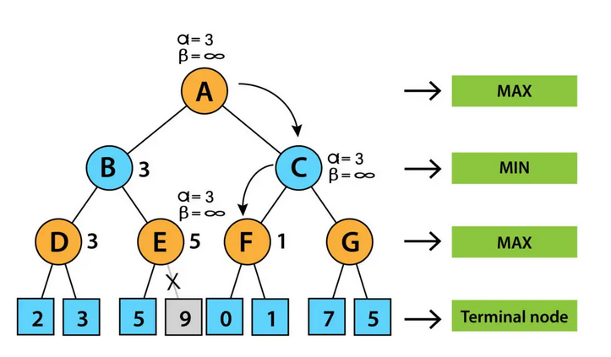

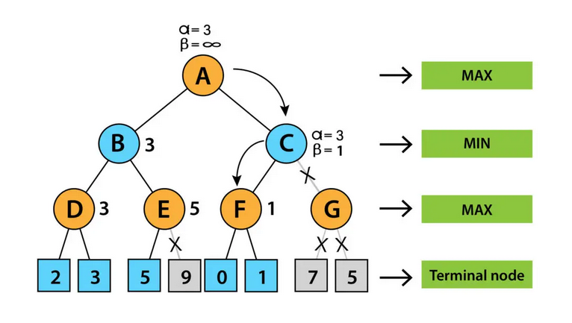

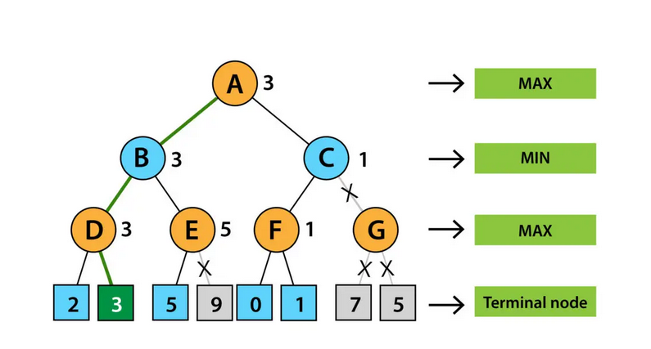One-line rule card for students
- Max node: update α = max(α, child); prune if α ≥ β.
- Min node: update β = min(β, child); prune if β ≤ α.
- Pruning never changes the final Minimax result; it just skips useless branches.

